Experiments 1 & 2: Conservation of Momentum in Explosions and Collisions
Materials
Power Macintosh or Windows PC | 2 PAScars with 10 cm gate attachment
LabPro or Universal Lab Interface | Dynamics track with feet and end stops
Logger Pro | 2 ring stands and 90º clamps
2 Vernier Photogates | Cart masses

Purpose
The purpose of this experiment is to quantitatively explore conservation of momentum for explosions, elastic and inelastic collisions.
Theory
When two carts collide with each other, or they explode apart from one another, the total momentum of both carts is conserved regardless of the situation, such that:
$\sum{p_{\text{before}}}=\sum{p_{\text{after}}}$
Since you will be using two carts in this lab investigation, the momentum before and after can be rewritten as:
$$p_{\text{cart}1(i)}+p_{\text{cart}2(i)}=p_{\text{cart}1(f)}+p_{\text{cart}2(f)}$$
And since p = mv, this relationship can be rewritten as:
$m_{\text{cart}1}v_{\text{cart}1(i)}+m_{\text{cart}2}v_{\text{cart}2(i)}=m_{\text{cart}1}v_{\text{cart}1(f)}+m_{\text{cart}2}v_{\text{cart}2(f)}$
In an explosion, both carts have no momentum before the event, so p_{before} = 0. Therefore, after the explosion, the total momentum of both carts must also be equal to zero. The reason for this is because momentum is a vector quantity, which takes the direction of the velocity vector into account. One should easily see that if one cart is moving to the right, it will have positive momenta, and if the other cart is moving to the left, it will have negative momenta. Therefore, when you sum them up, you should wind up with zero momentum. Hence, the relationship p_{before} = p_{after} = 0 will hold true.
The collision of two carts on a track can be described in terms of momentum conservation and, in some cases, energy conservation. If there is no net external force experienced by the system of two carts, then we expect the total momentum of the system to be conserved. This is true regardless of the force acting between the carts. In contrast, energy is only conserved when certain types of forces are exerted between the carts.
Collisions are classified as elastic (kinetic energy is conserved), inelastic (kinetic energy is lost) or completely inelastic (the objects stick together after collision). An example of an elastic collision is one in which the carts' bounce off each other with no loss of kinetic energy. In this experiment, magnetic bumpers are used to minimize the energy losses due to friction during the collision. In reality, this "elastic" collision is slightly inelastic. A completely inelastic collision is one in which the carts hit and stick to each other. In this experiment, this is accomplished with the hook-and-loop bumpers on the carts.
Pre-Lab
- Assume that you are doing an experiment with two carts of similar mass and speed from opposite ends of the track. You observed that when they collided that they stuck together and came to a complete stop. Is momentum conserved? Explain.
- Similarly, you experiment with two carts having the same mass and the same speed that collide and bounce off of each other elastically.
- Compare the final total momentum of each of the carts after they collide? Explain.
- What would be the relative difference of the magnitude of their momentums?
Setup
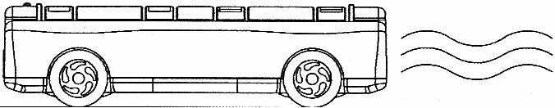
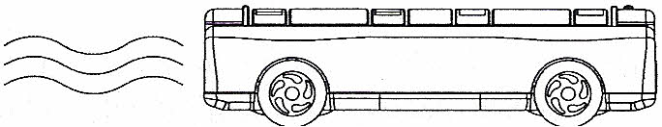
CART 1
CART 2
To LabPro
To LabPro
Photogate

Figure 1.1
- Install the feet on the track and level it.
- Install end stops at the ends of the track.
- Install the two photogates using the ring stands and place them as shown in the diagram. Make sure that there is ample room for both carts in the center of the track, as well at the ends of the track such that the cart will completely pass through the photogate prior to hitting the end stop. See figure 1.1.
- Complete all connections to the LabPro interface and the computer. Make sure that the photogate on the left is connected to DIG/SONIC 1 and the one on the right is connected to DIG/SONIC 2.
- Then start Logger Pro 3.5.0, and open up the file, Conservation of Momentum in the Student Assignments directory under Mr. Ropes.
- When prompted, click on Connect for each of the photogates. Your are now ready to collect your data.
Part I: Explosions
- Measure the masses of the carts and record in Table 1.1.
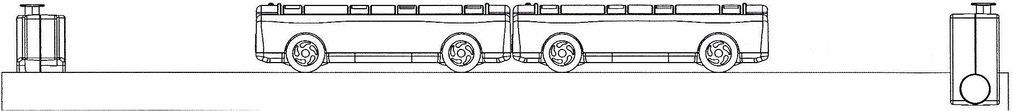
- For each of the cases in Table 1.1, place the two carts in the center of the track such that they are against each other with the plunger of one cart latched in the third position (completely recessed into the cart) and touching the opposite end of the other cart (see Figure 1.2). Push the plunger of the other cart all the way in to its storage position.
Figure 1.2

- After clicking on the  button, tap the plunger release button gently (you may want to use a pen or pencil to do this) and watch the two carts move to the ends of the track.
- Record the velocity value for each cart in Table 1.1. Repeat this process for the masses listed in Table 1.1.
Table 1.1: Results

Additional | Additional | m₁  _{(kg)} | m₂  _{(kg)} | v₁  _{(m/s)} | v₂  _{(m/s)} | p₁  _{(kg•m/s)} | p₂  _{(kg•m/s)} | p₁/p₂
Mass on | Mass on
Cart 1 | Cart 2
0 | 0
250g | 0 |  | ~ .
500g | 0
750g | 0
750g | 250g

Part II: Elastic Collisions
- NOTE: While testing cases A1 and A2, make sure that the collisions occur between the two photogates.
- Start with no mass in either of the carts.
- Orient the carts so that the plunger is fully extended on one of the carts towards the other.
- Record your values for velocity both before and after the collisions in Table 1.2.A1. It is of paramount importance that you note the direction, positive or negative of your carts both before and after the collision.

A. Carts with Equal Mass
Case A1: Place cart 2 at rest in the middle of the track. Give the other cart an initial velocity toward the cart at rest.
Case A2: Start the carts with one at each end of the track. Give each cart approximately the same velocity toward each other.

Table 1.2.A1: Results (Equal Mass)
Mass of Cart #1: |  |  | Mass of Cart #2:
Case Number | Velocity of cart 1 before collision  (m/s) | Velocity of cart 2 before collision  (m/s) | Velocity of cart 1 after collision  (m/s) | Velocity of cart 2 after collision  (m/s)
A1 |  | 0
A2

Part III: Completely Inelastic Collisions
- Orient the two carts so their hook-and-loop bumpers are toward each other. Push the plungers in all the way so they will not interfere with the collision.
- Repeat test cases AI through A2 and B1 through B3 and enter your data in Table 1.3.A1.
Table 1.3.A1: Results (Equal Mass)
Mass of Cart #1: |  |  | Mass of Cart #2:
Case Number | Velocity of cart 1 before collision  (m/s) | Velocity of cart 2 before collision  (m/s) | Velocity of cart 1 after collision  (m/s) | Velocity of cart 2 after collision  (m/s)
A1 |  | 0
A2

Data Analysis
- Summarize your data for each data set. For the elastic and inelastic collisions, use Tables 1.2.A2 and 1.3.A2.
- Part II: Elastic Collisions
Table 1.2.A2: Results (Equal Mass)
Mass of Cart #1: |  |  |  | Mass of Cart #2:
Case Number | Momentum of cart 1 before collision  (kg•m/s) | Momentum of cart 2 before collision  (kg•m/s) | Momentum of cart 1 after collision  (kg•m/s) | Momentum of cart 2 after collision  (kg•m/s) | Total momentum before collision  (kg•m/s) | Total momentum after collision  (kg•m/s) | Ratio of total momentum  after/before
A1 |  | 0
A2

- Part III: Inelastic Collisions

Table 1.3.A2: Results (Equal Mass)
Mass of Cart #1: |  |  |  | Mass of Cart #2:
Case Number | Momentum of cart 1 before collision  (kg•m/s) | Momentum of cart 2 before collision  (kg•m/s) | Momentum of cart 1 after collision  (kg•m/s) | Momentum of cart 2 after collision  (kg•m/s) | Total momentum before collision  (kg•m/s) | Total momentum after collision  (kg•m/s) | Ratio of total momentum  after/before
A1 |  | 0
A2

Questions
- If the total momentum for a system is the same before and after the explosion/collision, we say that momentum is conserved. If momentum were conserved,
- what would be the ratio of the momenta after the explosion?
- what would be the ratio of the total momentum after the collision to the total momentum before the collision?
- Does the ratio of the momentum in each case suggest that momentum was conserved during this investigation? Explain by referencing your data.
- During the explosion trials, when carts of unequal masses push away from each other, did one of the carts have more momentum than the other? Explain.
- During the explosion trials, did it matter which cart had the plunger? Why?
Error Analysis & Conclusions

Extensions:
If you finish all your data collection early, here is a chance for some EXTRA CREDIT (2 - 4 points).
- Determine the spring constant of the spring (Use the principle of conservation of energy).
- Calculate the kinetic energy for each trial.
- Based upon your calculations for kinetic energy
  - Was it conserved for the trials involving elastic collisions (Part II).
  - Was it conserved for the trials involving inelastic collisions (Part III).

